18.36: From 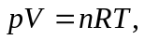 the temperature increases by a factor of 4 if the pressure and volume are each doubled. Then the rms speed 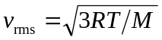increases by a factor of 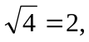 so the final rms speed is 